create table schoolmanagement

(school_name varchar(50),

school_address varchar(60),

ranking int);

insert into schoolmanagement

(school_name,school_address,ranking)

values

('krmm mat hr sec school','98f cannal bank road adyar chennai-20',33);

select *from schoolmanagement

create table Result

(student_id serial,

subject_id serial,

result_date varchar(50),

mark int,

result_year varchar(50));

insert into Result

(student_id,subject_id,result_date,mark,result_year)

values

(101,0233,'22july2023',80,'pass');

insert into Result

(student_id,subject_id,result_date,mark,result_year)

values

(102,0233,'22july2023',50,'pass');

insert into Result

(student_id,subject_id,result_date,mark,result_year)

values

(103,0233,'22july2023',85,'pass');

insert into Result

(student_id,subject_id,result_date,mark,result_year)

values

(104,0233,'22july2023',30,'fail');

insert into Result

(student_id,subject_id,result_date,mark,result_year)

values

(105,0233,'22july2023',31,'fail');

Select*from Result 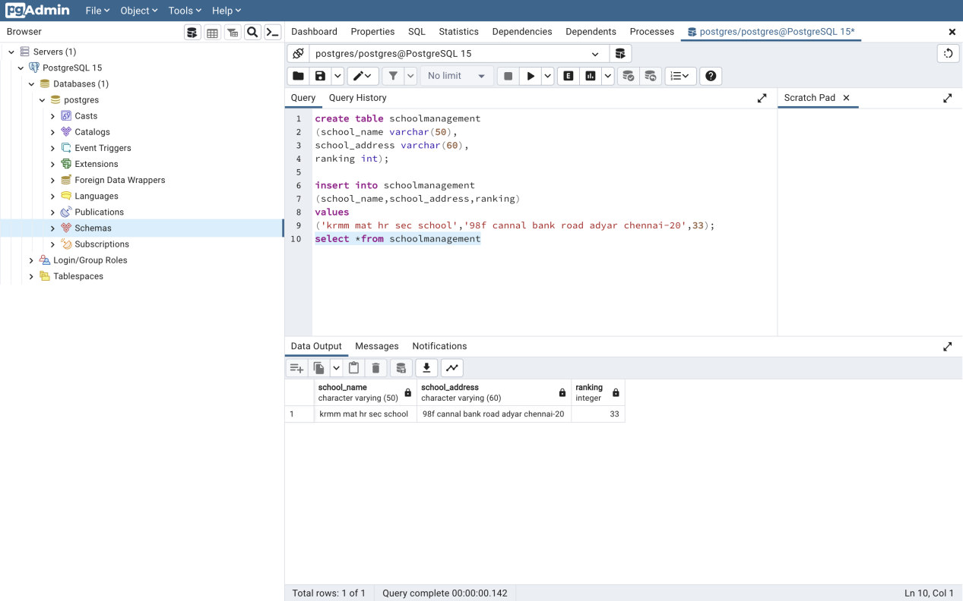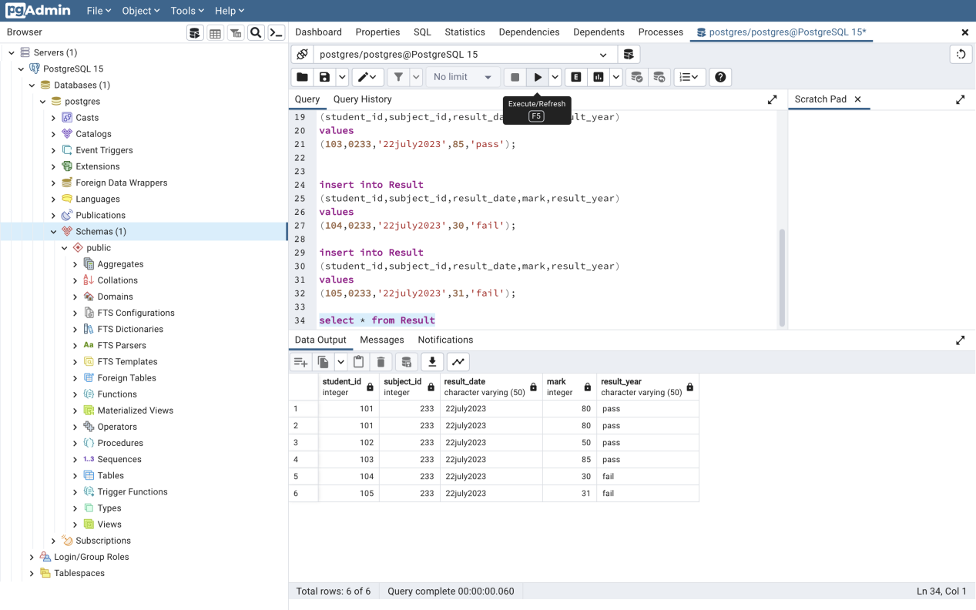

create table Attendance

(student_id serial,

attendance_date varchar(50),

No_of_absent int,

total_no_of_present int,

percentage varchar(50));

insert into Attendance

(student_id,attendance_date,No_of_absent,total_no_of_present,percentage)

values

(101,'20july2023',2,30,'90%');

insert into Attendance

(student_id,attendance_date,No_of_absent,total_no_of_present,percentage)

values

(102,'20june,21july,3auguest',2,30,'84%');

insert into Attendance

(student_id,attendance_date,No_of_absent,total_no_of_present,percentage)

values

(103,'20june',1,30,'98%');

insert into Attendance

(student_id,attendance_date,No_of_absent,total_no_of_present,percentage)

values

(104,'20july2023',2,30,'90%');

insert into Attendance

(student_id,attendance_date,No_of_absent,total_no_of_present,percentage)

values

(105,'21june',1,30,'97%');

select *from Attendance

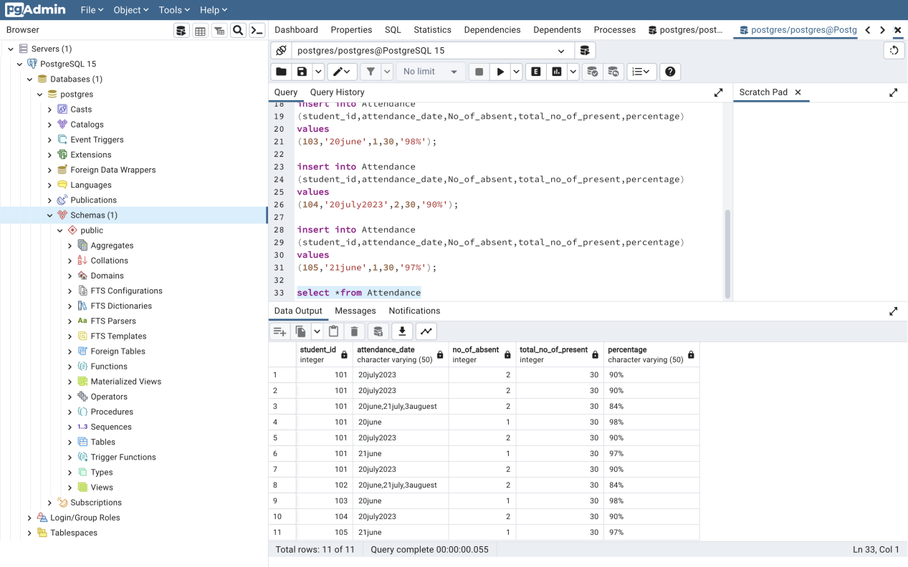

create table Admistion

(classes varchar(50),

feels_details varchar(50),

date_of_joining varchar(50),

student_id int,

rules_of_regulation varchar(50));

insert into Admistion

(classes,feels_details,date_of_joining,student_id,rules_of_regulation)

values

('10B','10 30000','20july2009',101,'');

insert into Admistion

(classes,feels_details,date_of_joining,student_id,rules_of_regulation)

values

('10B','10 30000','20july2009',102,'');

insert into Admistion

(classes,feels_details,date_of_joining,student_id,rules_of_regulation)

values

('10B','10 30000','21july2009',103,'');

insert into Admistion

(classes,feels_details,date_of_joining,student_id,rules_of_regulation)

values

('10B','10 30000','20july2009',104,'');

insert into Admistion

(classes,feels_details,date_of_joining,student_id,rules_of_regulation)

values

('10B','10 40000','21july2009',105,'');

select *from Admistion

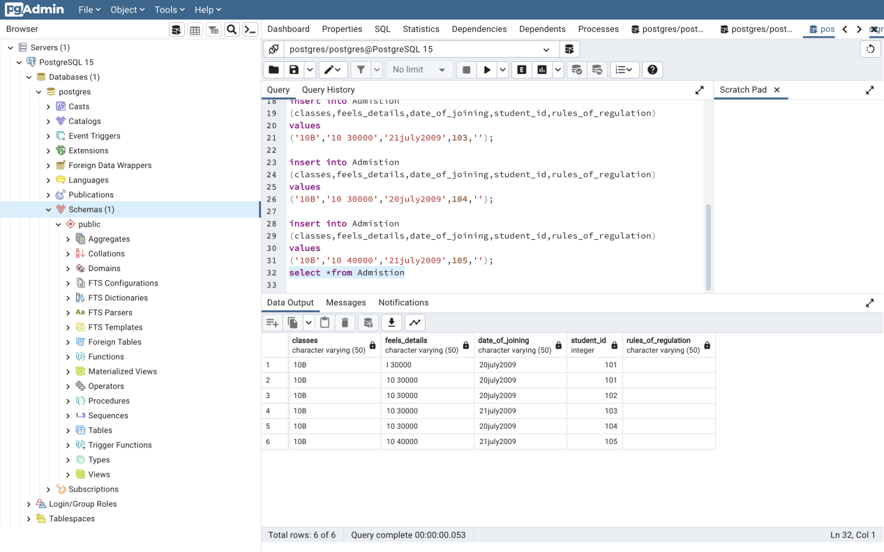

create table parent

(parent_id serial

parent_email varchar(50),

parent_father varchar(50),

parent_mather varchar(40),

occupation varchar(40),

phone_no serial,

annual_income int);

insert into parent

(parent_id,parent_email,parent_father,parent_mather,occuption,phone_no,annual_income)

values

[(101,'reemasatha@gmail.com','Sathabahadur','saraswathy','manager',9444991693,400000);](mailto:(101,'reemasatha@gmail.com','Sathabahadur','saraswathy','manager',9444991693,400000);)

create table Exam1

(exam_id int,

exam_name varchar(40),

subject varchar(70),

date_of_exam varchar(50));

insert into Exam1

(exam_id,exam_name,subject,date_of_exam)

values

(1220,'Quartely','Tamil','20sep2023');

insert into Exam1

(exam_id,exam_name,subject,date_of_exam)

values

(1221,'Quartely','English','20sep2023');

insert into Exam1

(exam_id,exam_name,subject,date_of_exam)

values

(1222,'Quartely','Maths','20sep2023');

insert into Exam1

(exam_id,exam_name,subject,date_of_exam)

values

(1223,'Quartely','Social','20sep2023');

insert into Exam1

(exam_id,exam_name,subject,date_of_exam)

values

(1224,'Quartely','Science','20sep2023');

select *from Exam1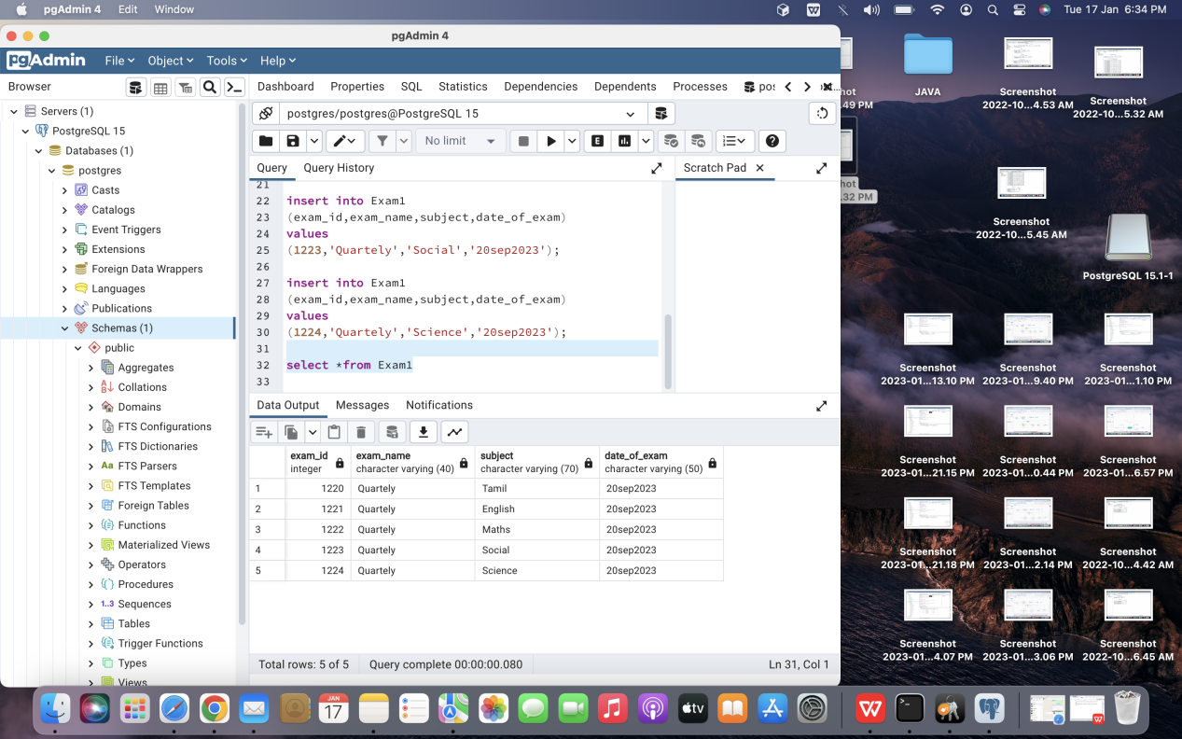

create table class_table

(class_id varchar(50),

student_id serial,

teacher_id serial);

insert into class_table

(class_id,student_id,teacher_id)

values

('10A',5567,099);

insert into class_table

(class_id,student_id,teacher_id)

values

('10B',5568,081);

insert into class_table

(class_id,student_id,teacher_id)

values

('9A',5544,098);

insert into class_table

(class_id,student_id,teacher_id)

values

('8A',5560,093);

insert into class_table

(class_id,student_id,teacher_id)

values

('10B',5577,092);

select*from class_table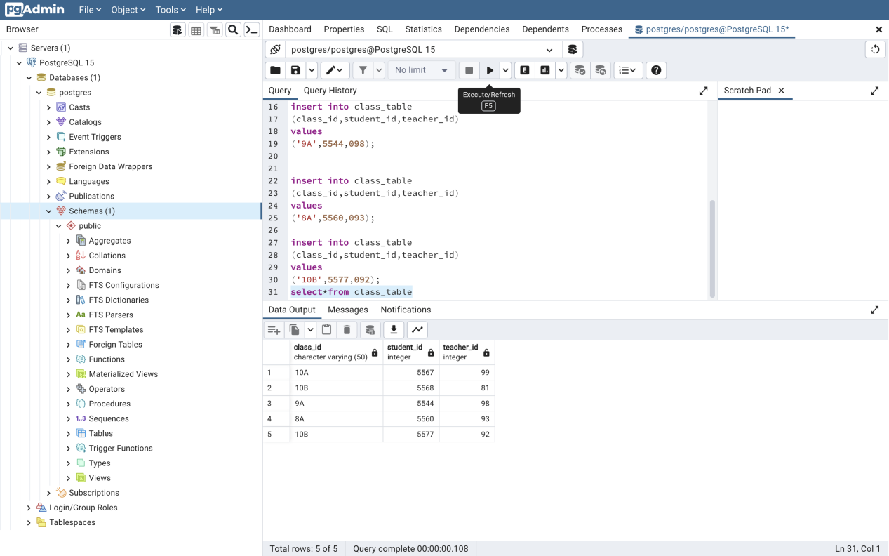

create table time_table3

(classes varchar(30),

time_table varchar(30));

insert into time_table3

(classes,time_table)

values

('11 A','I period biology');

insert into time_table3

(classes,time_table)

values

('11 A','II period English');

insert into time_table3

(classes,time_table)

values

('11 A','III period German');

insert into time_table3

(classes,time_table)

values

('11 A','IV period Maths');

insert into time_table3

(classes,time_table)

values

('11 A','V period Biology practial');

select *from time_table3

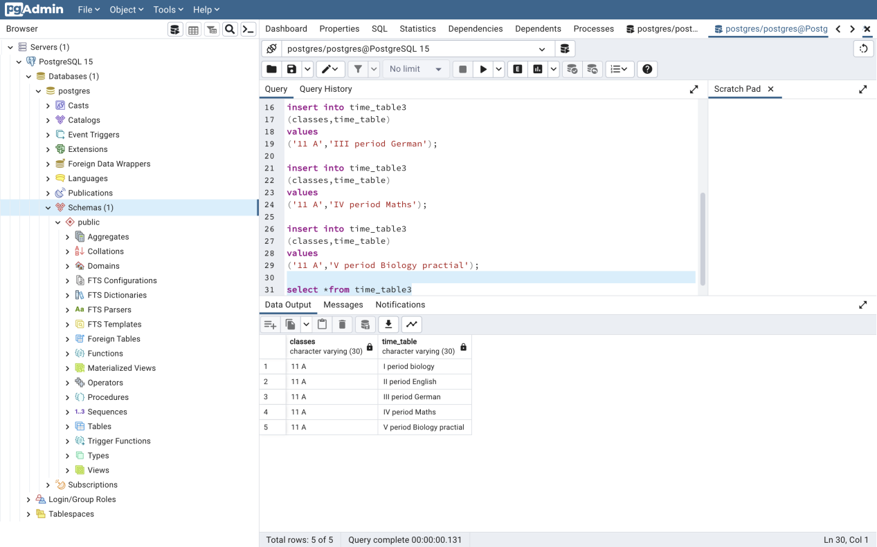

insert into student

(stu_id,stu_name,stu_email,stu_phone,stu_gender,stu_address,stu_dob,stu_class,stu_team)

values

(5567,'Reema','reema@gmail.com','9677243794','female','98fcanal bank road chennai20','27june2003','10A','ruby');

insert into student

(stu_id,stu_name,stu_email,stu_phone,stu_gender,stu_address,stu_dob,stu_class,stu_team)

values

(5568,'Abinaya','abi@gmail.com','967725678','female','22f rayapuram chennai-20','20Auguest2003','10A','emarald');

insert into student

(stu_id,stu_name,stu_email,stu_phone,stu_gender,stu_address,stu_dob,stu_class,stu_team)

values

(5569,'Sanjay','sanjay@gmail.com','9445280528','female','perumal kovil street chennai-25','11june2003','10A','ruby');

insert into student

(stu_id,stu_name,stu_email,stu_phone,stu_gender,stu_address,stu_dob,stu_class,stu_team)

values

(5570,'Thendral','Thendral@gmail.com','9677234007','female','38 gandhi nagar 3 main street chennai-20','21Auguest2003','10A','pearl');

insert into student

(stu_id,stu_name,stu_email,stu_phone,stu_gender,stu_address,stu_dob,stu_class,stu_team)

values

(5571,'kavin','kavin@gmail.com','9176283254','female','98fcanal bank road second street chennai-21','13Nov2003','10A','supphire');

insert into student

(stu_id,stu_name,stu_email,stu_phone,stu_gender,stu_address,stu_dob,stu_class,stu_team)

values

(5572,'lakshaya','lux@gmail.com','9444991693','female','98fcanal bank road 3rd street chennai-20','24march2003','10A','Sapphihe');

select *from student

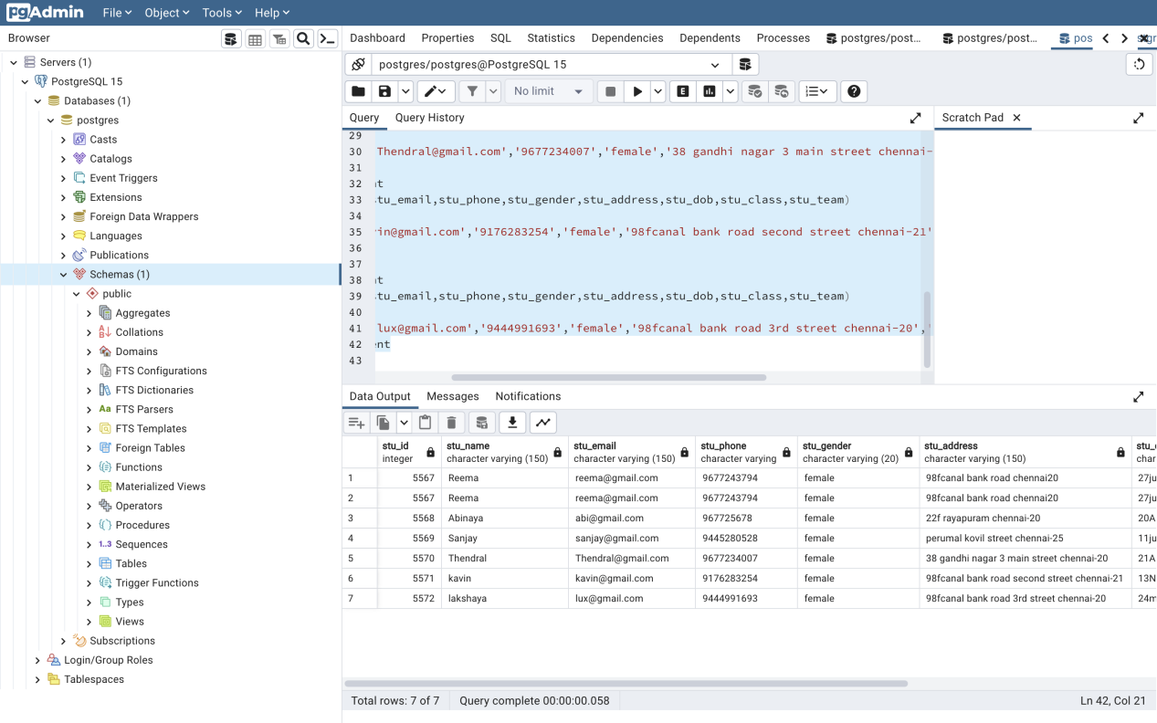

create table Teacher

(tr_id serial primary key,

tr_name varchar(150),

tr_email varchar(150),

tr_phone varchar,

tr_gender varchar(20),

tr_address varchar(150),

tr_dob varchar(150),

tr_class varchar(50),

tr_team varchar(150));

insert into Teacher

(tr_id,tr_name,tr_email,tr_phone,tr_gender,tr_address,tr_dob,tr_class,tr_team)

values

(555,'Vijiyalaxmi','viji@gmail.com','9677243794','female','98fcanal bank road chennai20','27june2003','10A','ruby');

insert into Teacher

(tr_id,tr_name,tr_email,tr_phone,tr_gender,tr_address,tr_dob,tr_class,tr_team)

values

(556,'Abinaya','abi@gmail.com','967725678','female','22f rayapuram chennai-20','20Auguest2003','10A','emarald');

insert into Teacher

(tr_id,tr_name,tr_email,tr_phone,tr_gender,tr_address,tr_dob,tr_class,tr_team)

values

(557,'Sanjay','sanjay@gmail.com','9445285678','male','perumal kovil street chennai-25','11june2003','10A','ruby');

insert into Teacher

(tr_id,tr_name,tr_email,tr_phone,tr_gender,tr_address,tr_dob,tr_class,tr_team)

values

(558,'Mala','mala@gmail.com','9876543890','female','38 gandhi nagar 4 main street chennai-20','21Auguest2003','10A','pearl');

select *from Teacher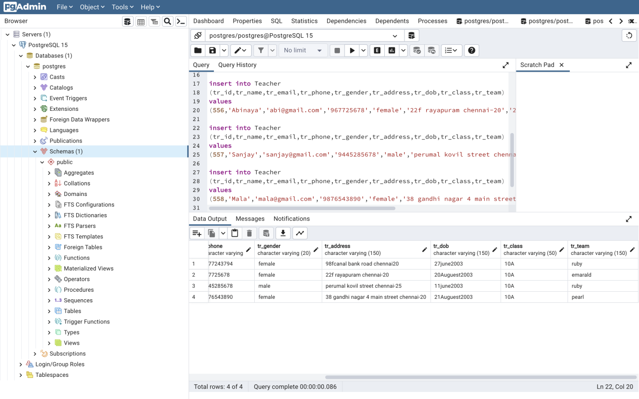

create table parent

(parent_id serial,

parent_email varchar(50),

parent_father varchar(50),

parent_mather varchar(40),

occupation varchar(40),

phone_no bigint,

annual_income int);

insert into parent

(parent_id,parent_email,parent_father,parent_mather,occupation,phone_no,annual_income)

values

(5567,'satha@gmail.com','Sathabahadur','saraswathy','manager',9444991693,400000);

insert into parent

(parent_id,parent_email,parent_father,parent_mather,occupation,phone_no,annual_income)

values

(5568,'vasudevan@gmail.com','Vasudeyvan','Nisha','HR',9444997883,500000);

insert into parent

(parent_id,parent_email,parent_father,parent_mather,occupation,phone_no,annual_income)

values

(5569,'MAGESH@gamil.com','magesh','sasikala','Owner',9445280528,400000);

insert into parent

(parent_id,parent_email,parent_father,parent_mather,occupation,phone_no,annual_income)

values

(5570,'Rangaraju@gmail.com','Rangarajan','Uma','Developer',9446789693,10000000);

insert into parent

(parent_id,parent_email,parent_father,parent_mather,occupation,phone_no,annual_income)

values

(5571,'panner@gmail.com','Panner selvan','santhi','enginer',9677234007,600000);

select * from parent;

[GROUP BY AND ORDER BY (QUERY)]

1. Display Count of Teacher based on class or tr_id

QUERY:

select count(tr_id) from Teacher GROUP BY tr_class;

**OUTPUT:**

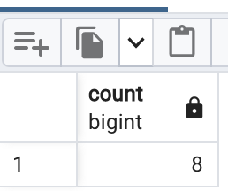

2. Display the mininum mark and maximum mark of students

QUERY:

select max(mark),min(mark) from Result GROUP BY student_id;

**OUTPUT:**

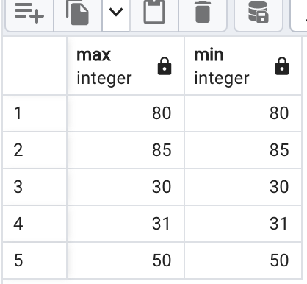

[SINGLE ROW FUNCTION]

1. count the length of schoolname characters

QUERY:

select length(school_name) from schoolmanagement;

**OUTPUT:**

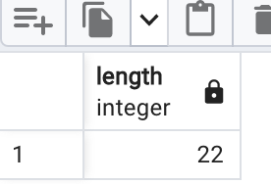

2.Display number of absent of number of parents together(cancat)

QUERY:

select concat(tr_id,tr_name)from Teacher;

**OUTPUT:**

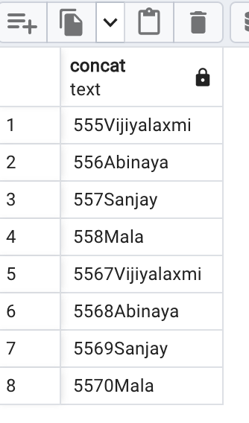

.AGGREGATE FUNCTION

1.Find the average mark of all student

QUERY:

select avg(mark) from Result;

**OUTPUT:**

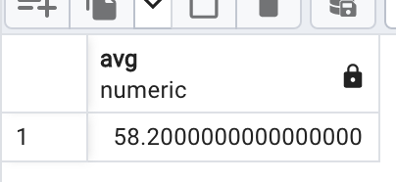

2.Display student name in descending order.

QUERY:

select * from student order by stu_id desc;

**OUTPUT:**

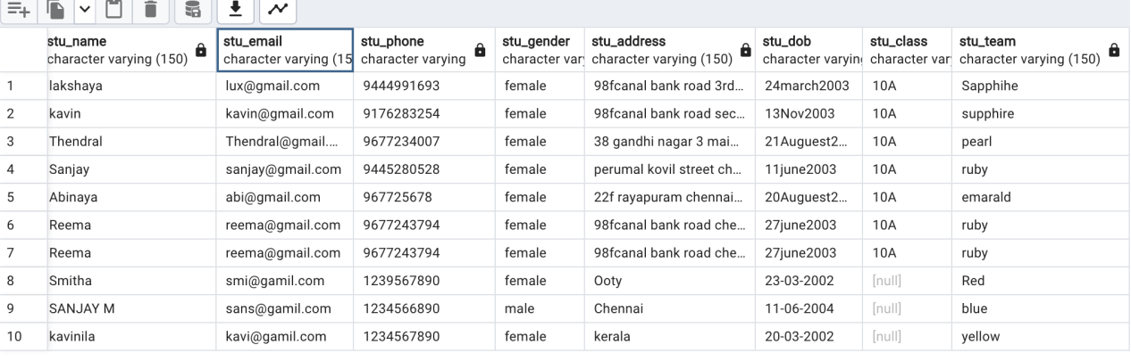

SET OPERATION

1.Display the all students and teacher in the school.

QUERY:

select *from student UNION select * from Teacher;

**OUTPUT:**

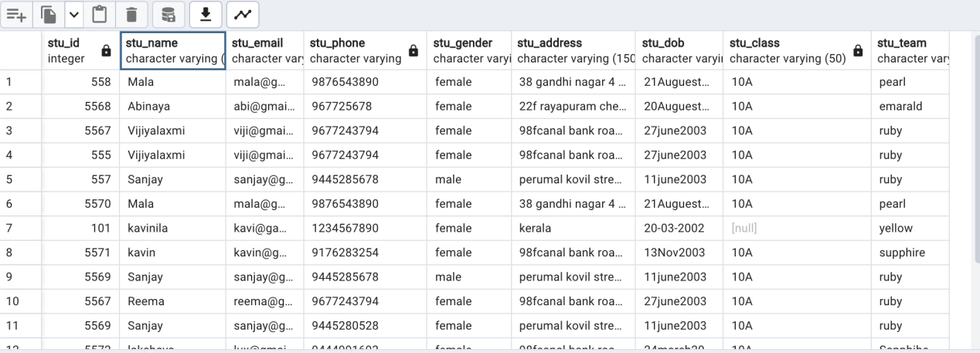

2.Display the list of student who where working as or teacher not as a student

QUERY:

select* from student except select*from Teacher;

**OUTPIUT:**

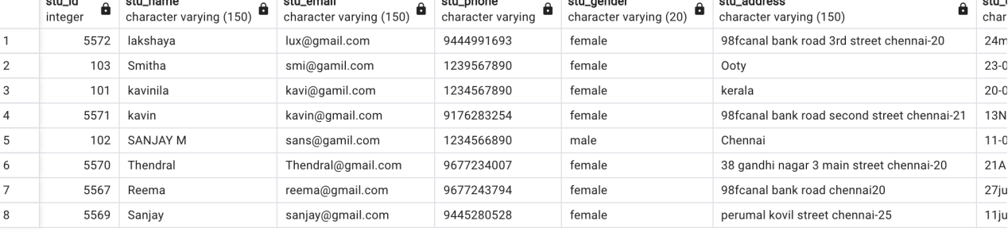

[JOIN]

1.Display all the student_id and the teacher id

QUERY:

select stu_id,stu_name,tr_id,tr_name from Teacher join student on stu_id=tr_id

**OUTPUT:**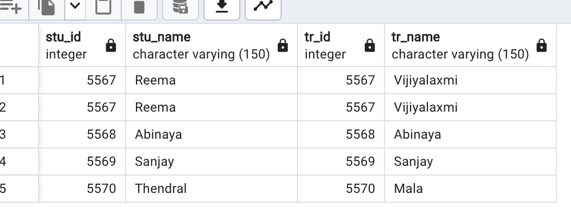

2.Display the records from both the table

QUERY:

select * from Result cross join Timetable;

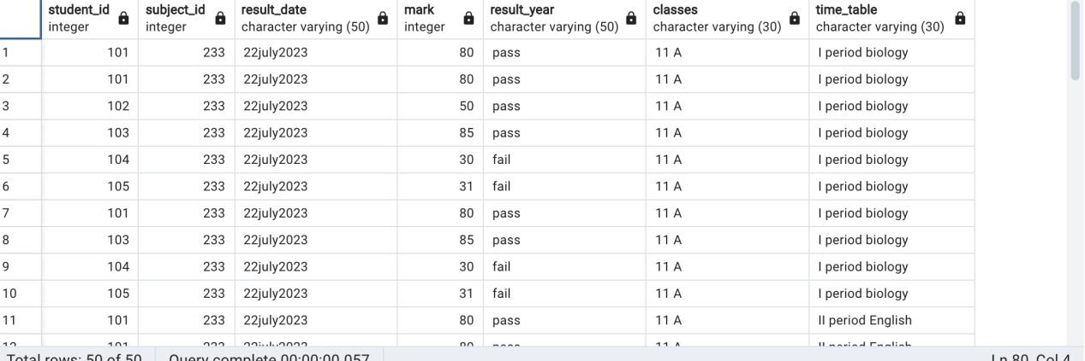

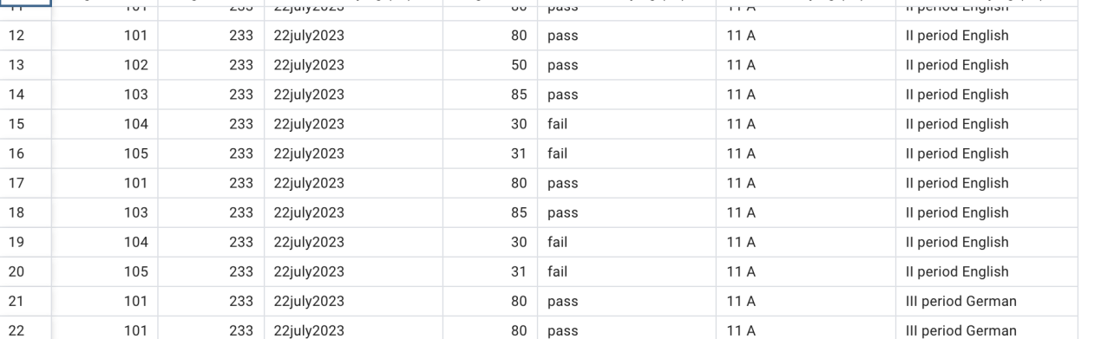

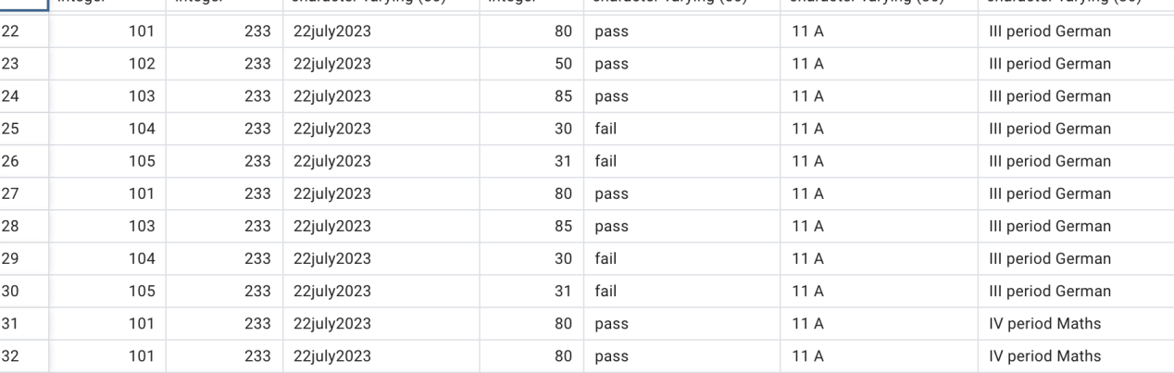

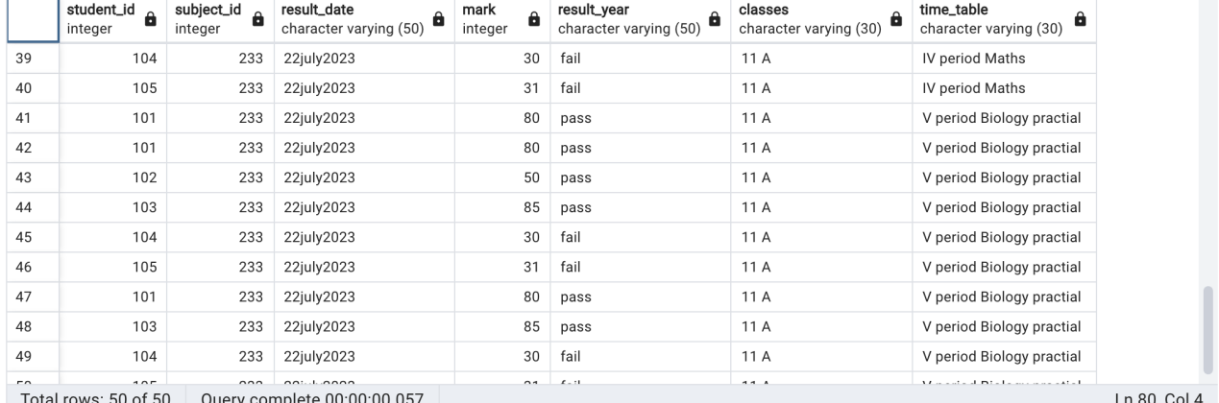

[VIEW,INDEX,SEQUENCE]

1.create a index for the field phone number

QUERY:

create index stu_phone_Index on student(stu_phone);

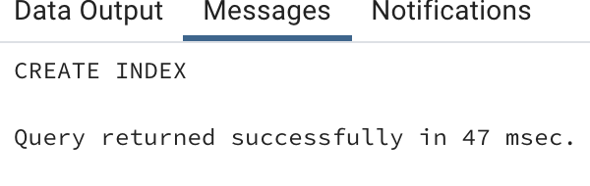

VIEW

create a view called parent_job with column (parent_id parent name,parent email,parent income)and set of data where parent job 'manager' from the table.

create view parent_job as

select parent_id,parent_father,parent_email,annual_income from parent

where occupation='manager';

select all the fields of the view

select * from parent_job;

**OUTPUT:**

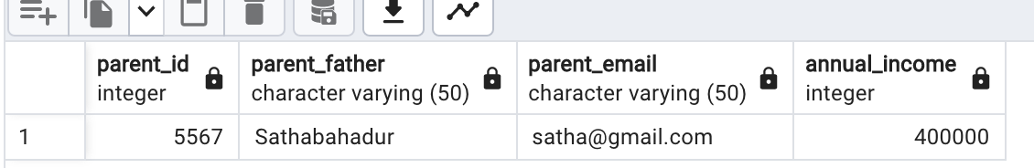

[SUBQUERIES]

1.Display the student and teacher id if both same.

QUERY:

select stu_name,stu_id from student where stu_id=(select tr_id from Teacher where tr_id=5567);

**OUTPUT:**

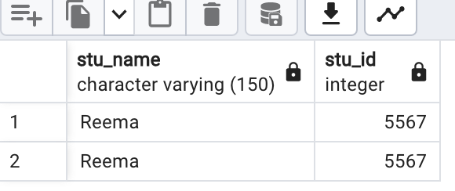

2.Fetch the details of parent using subquery

QUERY:

select stu_name,stu_id from student where stu_id=(select parent_id from parent where parent_id=5568);

**OUTPUT:**

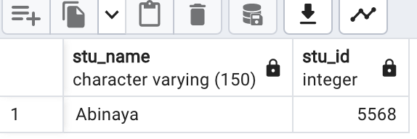

FUNCTION:

create or replace function myfun(x integer)

returns text as $$

declare

msg text;

begin

case

when x in(student)then

msg:='the table'

when x in(" ") then

msg:='the empty table';

create table Teacher

(tr_id serial primary key,

tr_name varchar(150),

tr_email varchar(150),

tr_phone varchar,

tr_gender varchar(20),

tr_address varchar(150),

tr_dob varchar(150),

tr_class varchar(50),

tr_team varchar(150));

insert into Teacher

(tr_id,tr_name,tr_email,tr_phone,tr_gender,tr_address,tr_dob,tr_class,tr_team)

values

(5567,'Vijiyalaxmi','viji@gmail.com','9677243794','female','98fcanal bank road chennai20','27june2003','10A','ruby');

insert into Teacher

(tr_id,tr_name,tr_email,tr_phone,tr_gender,tr_address,tr_dob,tr_class,tr_team)

values

(5568,'Abinaya','abi@gmail.com','967725678','female','22f rayapuram chennai-20','20Auguest2003','10A','emarald');

insert into Teacher

(tr_id,tr_name,tr_email,tr_phone,tr_gender,tr_address,tr_dob,tr_class,tr_team)

values

(5569,'Sanjay','sanjay@gmail.com','9445285678','male','perumal kovil street chennai-25','11june2003','10A','ruby');

insert into Teacher

(tr_id,tr_name,tr_email,tr_phone,tr_gender,tr_address,tr_dob,tr_class,tr_team)

values

(5570,'Mala','mala@gmail.com','9876543890','female','38 gandhi nagar 4 main street chennai-20','21Auguest2003','10A','pearl');

select *from Teacher

CURSOR

begin ;

declare

mycursor cursor for select* from student;

1. Display first 2 records from student table

fetch 2 from mycursor;

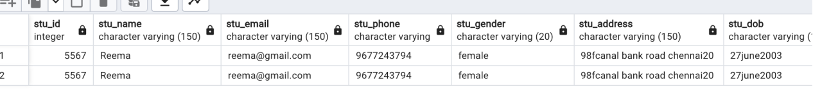

2.display the before record.

fetch prior from mycursor;

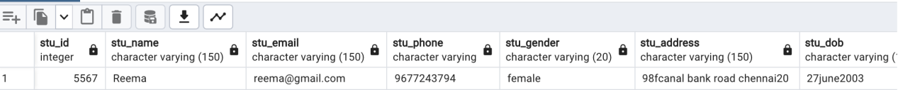

commit

SEQUENCE

create sequence result1

start 10

increment 20

minvalue 10

owned by Result.student_id;

insert into Result

(student_id,subject_id,result_date,mark,result_year)

values

(101,0233,'22july2023',80,'pass');

insert into Result

(student_id,subject_id,result_date,mark,result_year)

values

(102,0233,'22july2023',50,'pass');

insert into Result

(student_id,subject_id,result_date,mark,result_year)

values

(103,0233,'22july2023',85,'pass');

insert into Result

(student_id,subject_id,result_date,mark,result_year)

values

(104,0233,'22july2023',30,'fail');

insert into Result

(student_id,subject_id,result_date,mark,result_year)

values

(105,0233,'22july2023',31,'fail');

select * from Result;

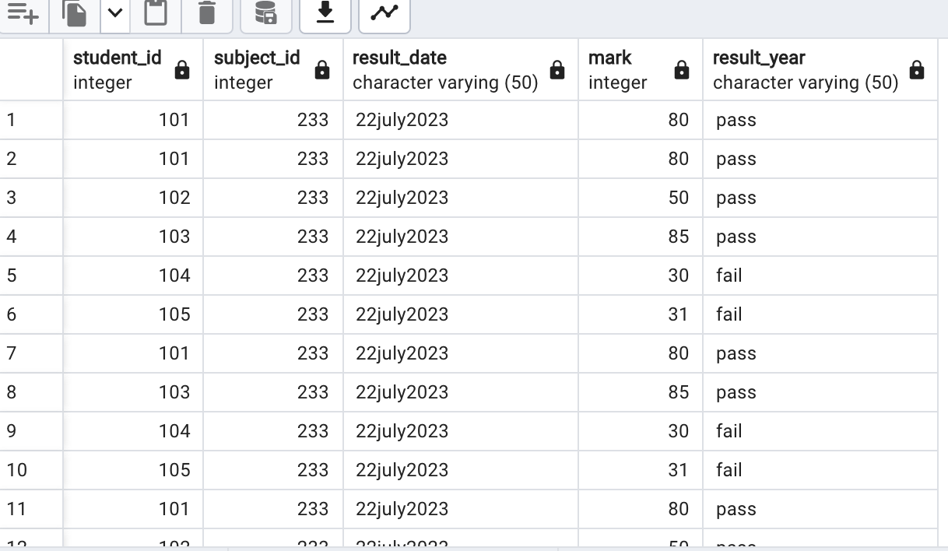

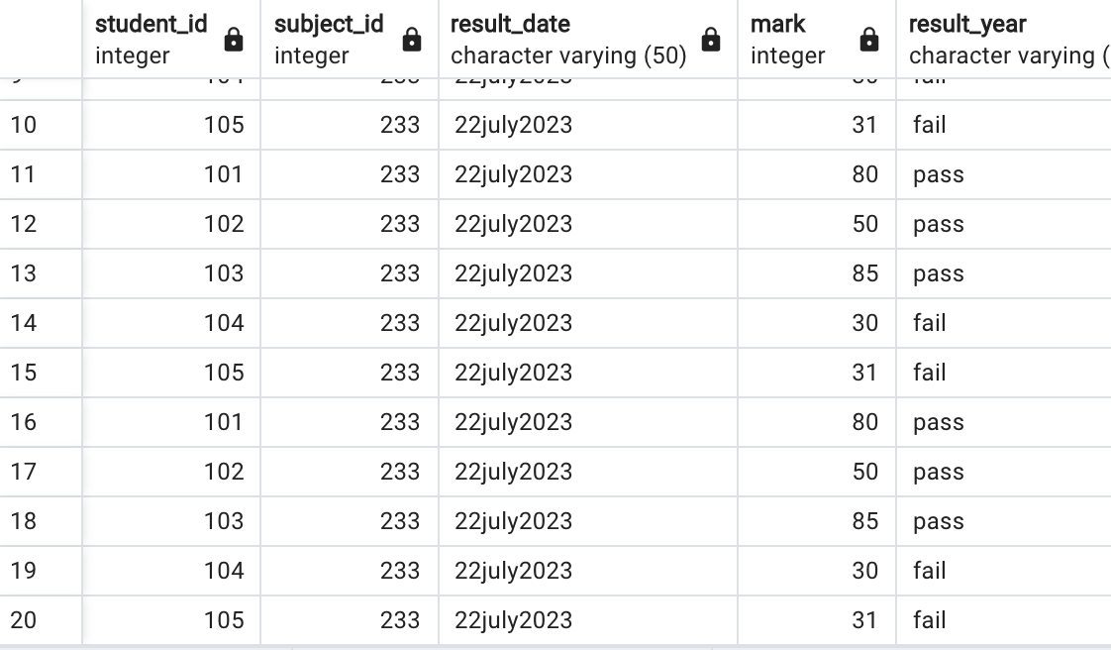

PROCEDURE

create table mark_stu1

(id int generated by default as identity ,

name varchar(30),

mark int,

mark1 int,

mark2 int,

mark3 int,

mark4 int,

total dec(15,2) not null);

insert into mark_stu1

(id,name,mark,mark1,mark2,mark3,mark4,total)

values

(5567,'Reema',80,30,40,50,60,260);

insert into mark_stu1

(id,name,mark,mark1,mark2,mark3,mark4,total)

values

(5568,'Abinaya',60,80,40,50,60,290);

insert into mark_stu1

(id,name,mark,mark1,mark2,mark3,mark4,total)

values

(5569,'Sanjay',90,50,98,57,70,365);

insert into mark_stu1

(id,name,mark,mark1,mark2,mark3,mark4,total)

values

(5570,'Thendral',85,40,70,90,50,335);

insert into mark_stu1

(id,name,mark,mark1,mark2,mark3,mark4,total)

values

(5571,'Kavin',80,30,50,50,70,280);

select * from mark_stu1;

create or replace procedure transfer(sender int,receiver int,amount dec)

language plpgsql

as $$

begin

update accounts

set balance=balance-amount where id =sender;

update accounts

set balance=balance+amount where id =receiver;

end;

$$

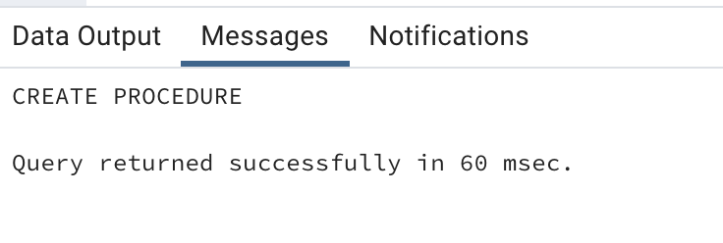

select * from mark_stu1;

call transfer(1,2,20);

FUNCTION

create table Result

(student_id serial,

subject_id serial,

result_date varchar(50),

mark int,

result_year varchar(50));

insert into Result

(student_id,subject_id,result_date,mark,result_year)

values

(101,0233,'22july2023',80,'pass');

insert into Result

(student_id,subject_id,result_date,mark,result_year)

values

(102,0233,'22july2023',50,'pass');

insert into Result

(student_id,subject_id,result_date,mark,result_year)

values

(103,0233,'22july2023',85,'pass');

insert into Result

(student_id,subject_id,result_date,mark,result_year)

values

(104,0233,'22july2023',30,'fail');

insert into Result

(student_id,subject_id,result_date,mark,result_year)

values

(105,0233,'22july2023',31,'fail');

Select*from Result

create or replace function

total()

Returns integer

as $$

declare

total integer;

begin

select count(*) into total from Result;

Return total;

end;

$$ language 'plpgsql';

select * from total;

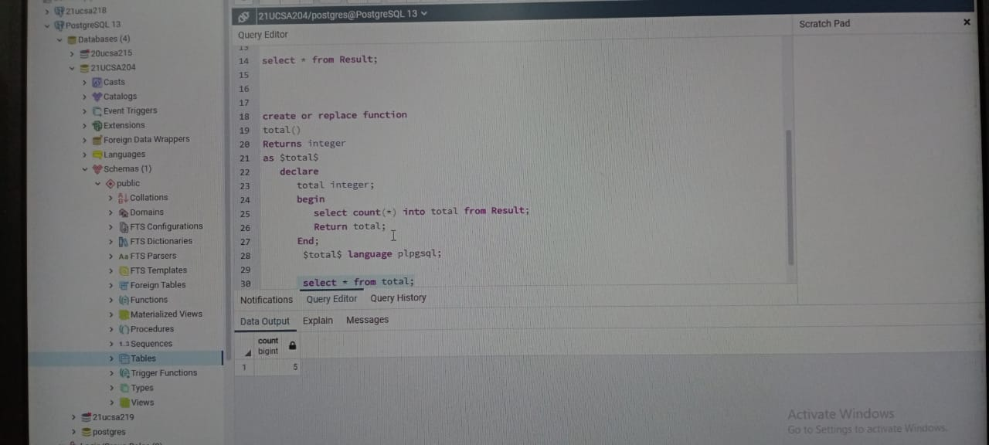

create or replace function

max()

returns integer

as $max$

declare

max integer;

begin

select max(mark) into max from Result;

Return max;

end;

$max$ language 'plpgsql';

select * from max;

TRIGGER

create or replace function comp_trigger_insert_fun()

Returns trigger

as $$

Begin

insert into stu_it

(stu_id,Entry_date)

values

(new.stu_id,current_date);

Return new;create

end;

$$

language 'plpgsql'

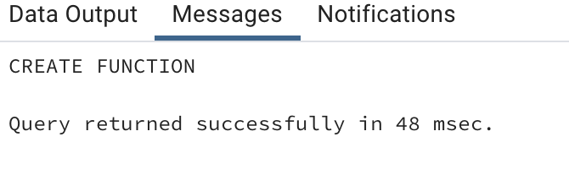

create trigger comp_trigger_insert1

after insert

on Teacher

for each row

execute procedure comp_trigger_insert_fun();

insert into Teacher

(tr_gender)

values

('female');

insert into Teacher

(tr_gender)

values

('male');

insert into Teacher

(tr_gender)

values

('female');

select* from Teacher;